**Covid UseCase Using DataBricks**

**Reading the files using python in DataBricks** 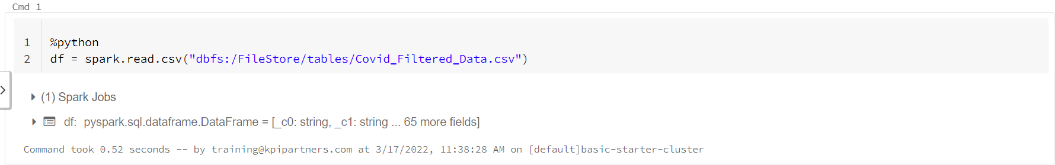

**Creating the Temporary View:**

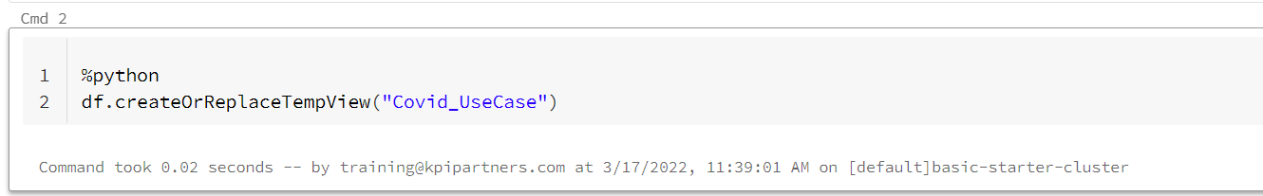

**Queries using SQL:**

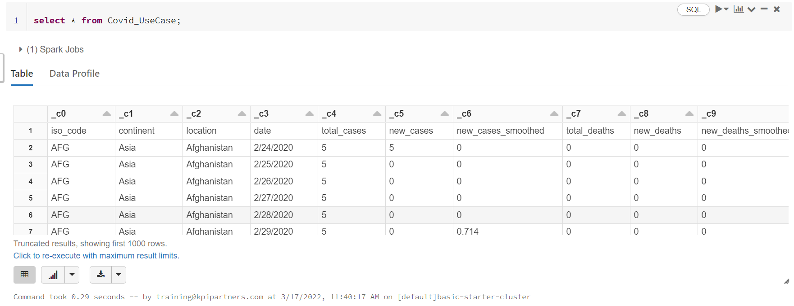

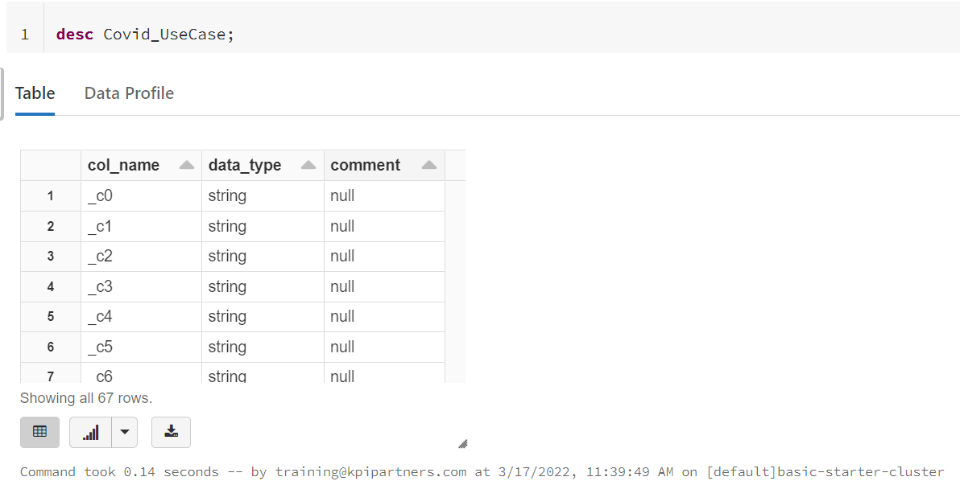

**3. Positivity rate where the stringency index is maximum**

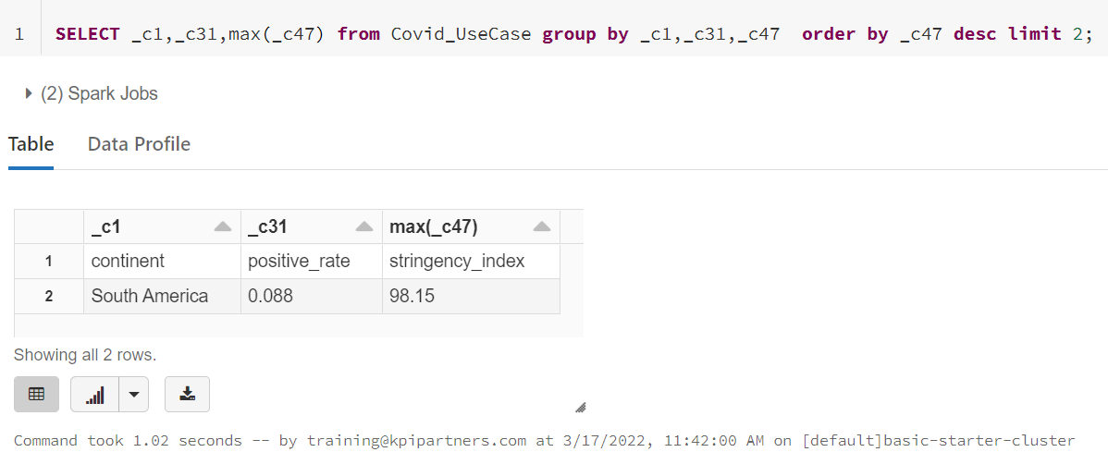

**4. Which continent and location having max of deaths and male_smokers**

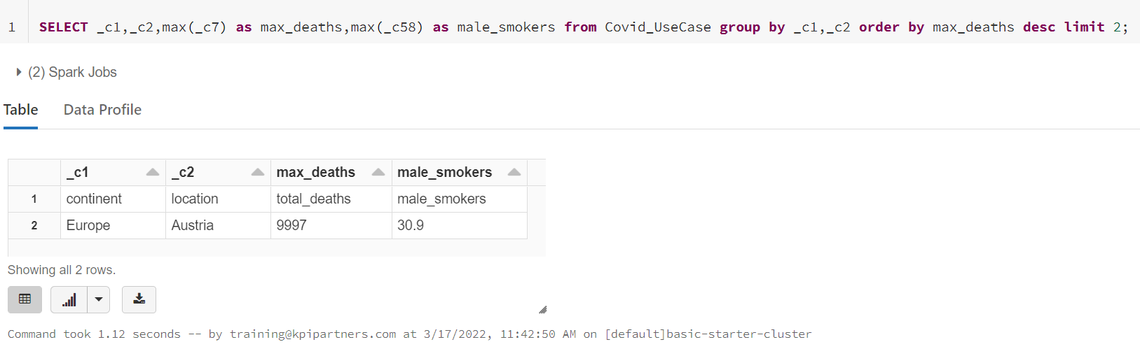

**5. Which year having the highest number of deaths**

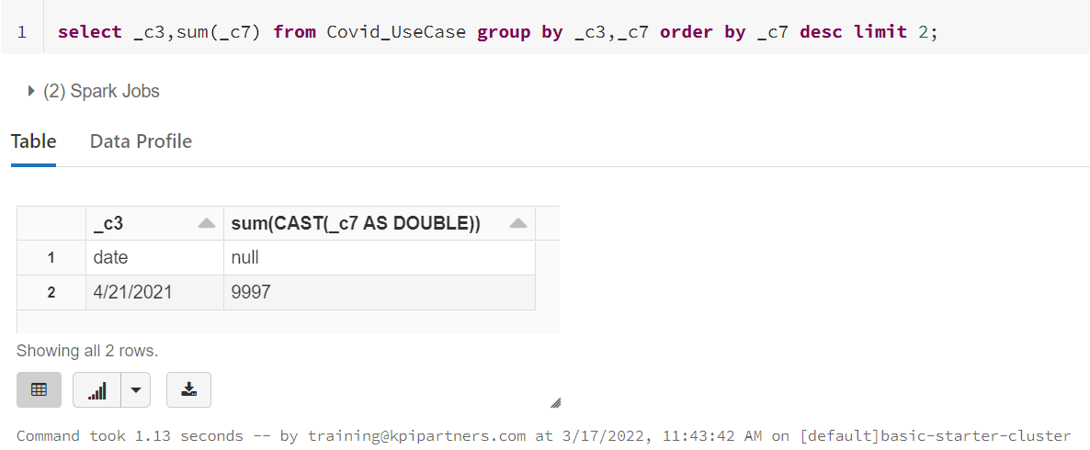

**6. Which location having lowest recovery rate for each continent**

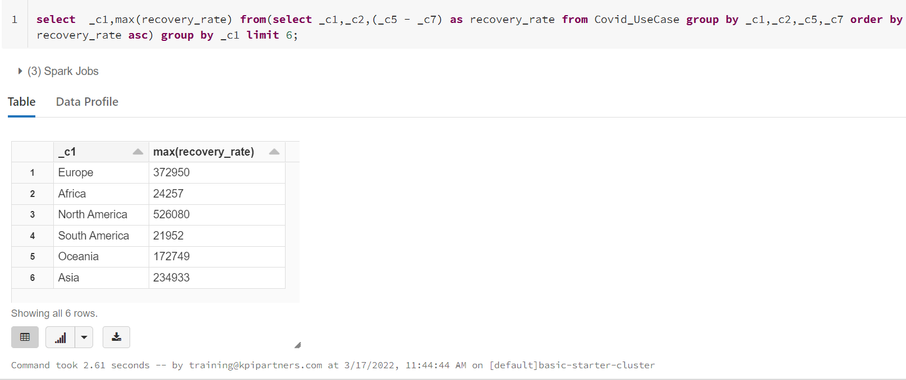

**7. Countries with max cardiovasc_death_rate and diabetes_prevalence greater than 10**

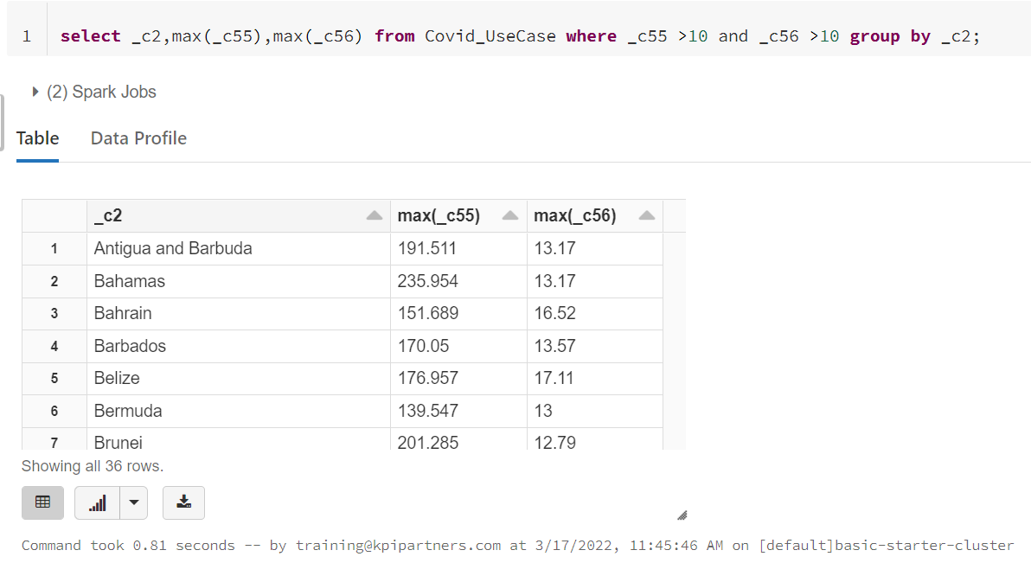

**8. Which location has highest number of vaccinated people in each continent**

